Course Code: CSA1557

Course Name: Cloud Computing and Big Data Analytics

M.Gowripriya

192224223

2) Create a simple cloud software application for Property Buying & Rental process (In Chennai city) using any Cloud Service Provider to demonstrate SaaS include the necessary fields such as Buy, Rent, commercial, Rental Agreement , Rental Agreement, Area, place, Range, property value etc.

AIM: To Create a simple cloud software application for Property Buying & Rental process (In Chennai city) using any Cloud Service Provider to demonstrate SaaS.

PROCEDURE:

Step1: Go to zoho.com.

Step 2: Log into the zoho.com.

Step 3: Select one application step.

Step4: Enter application name as property buying & rental.

Step 5: Created new application as property buying & rental.

Step 6: Select one form

Step 7: The software has been created.

IMPLEMENTATION:

STEP1: GOTO ZOHO.COM

STEP1: GOTO ZOHO.COM

STEP 2: LOGINTOTHE ZOHO.COM

STEP 3: SELECT ONE APPLICATION

STEP 4: ENTER APPLICATION NAME

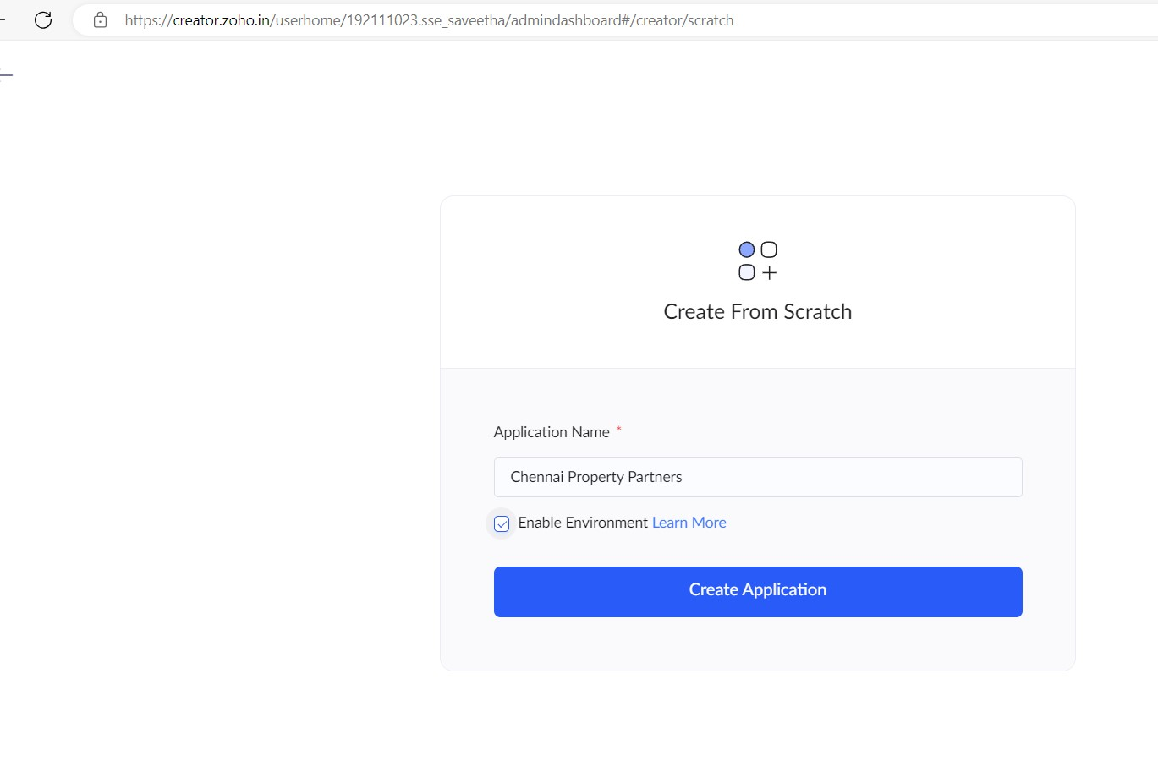

STEP 5: Created New Application

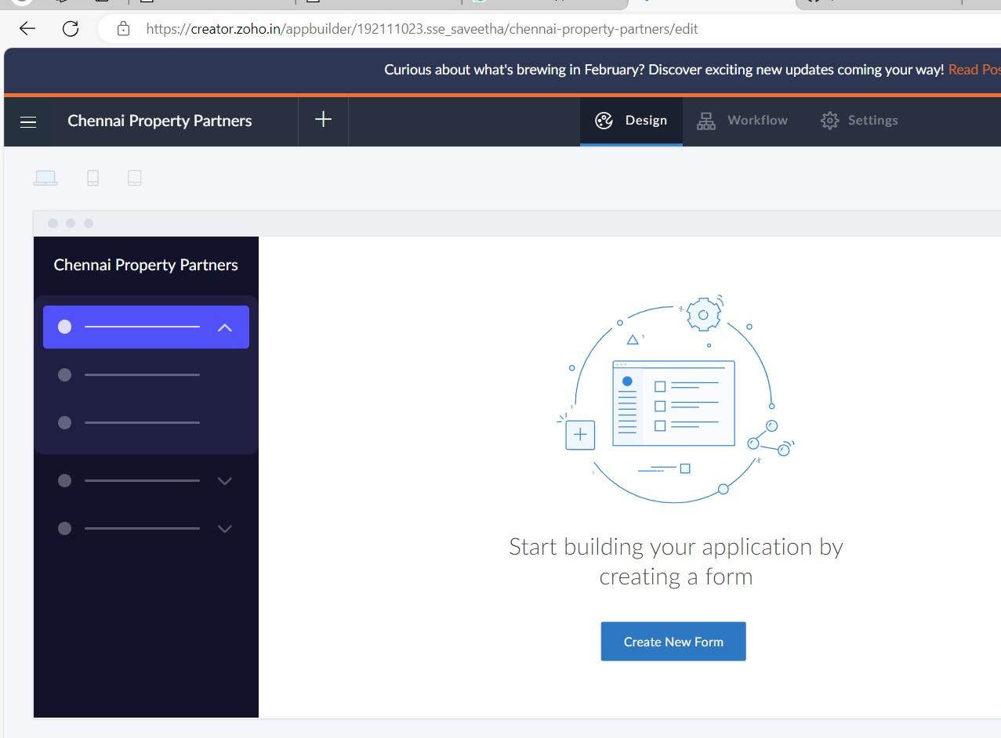

STEP 6: Select from Stratch and Create form as login.

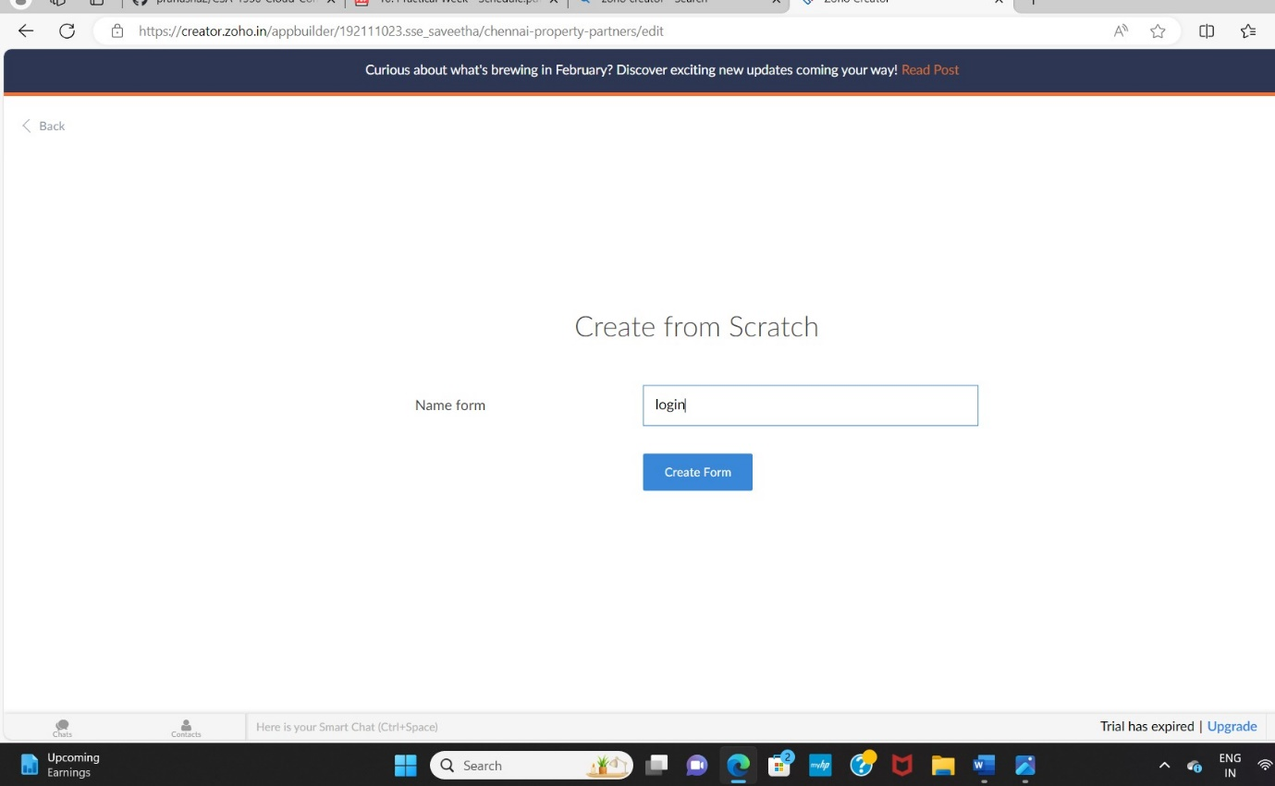

STEP 7: The form has been created as login.

Choose the fields.

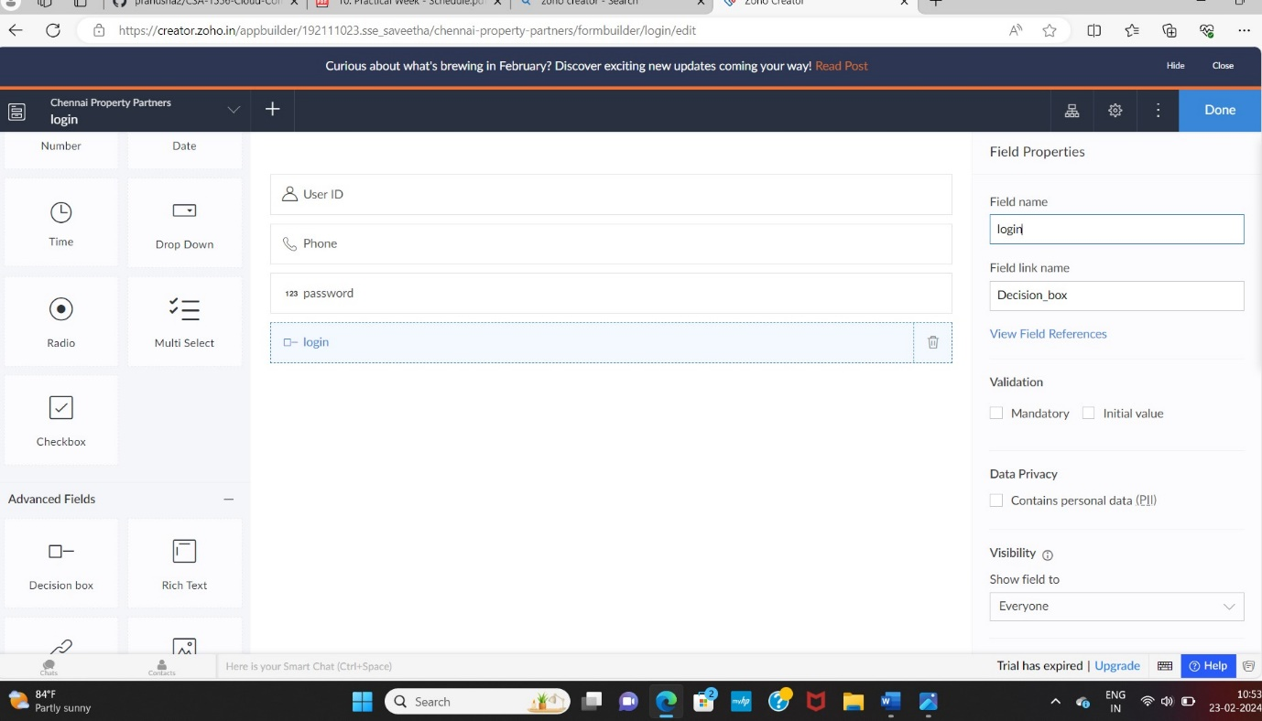

STEP 8: Click Access Development Live and enter the details to access.

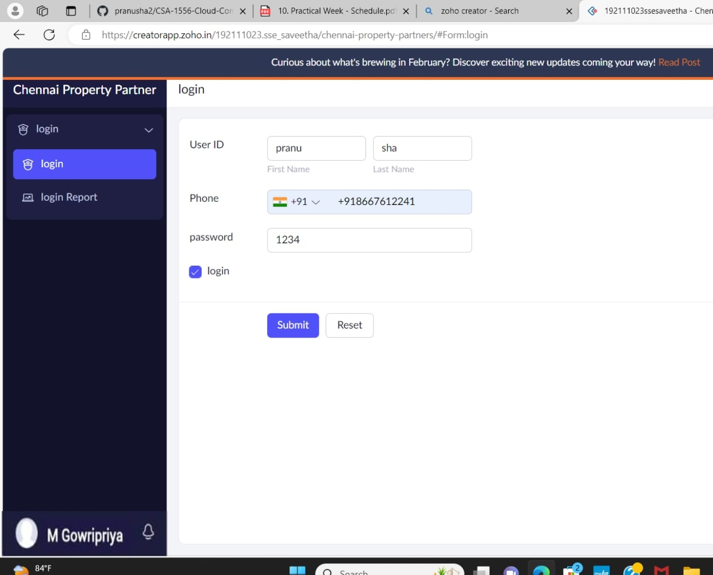

STEP 9: The report has been registered in the login report.

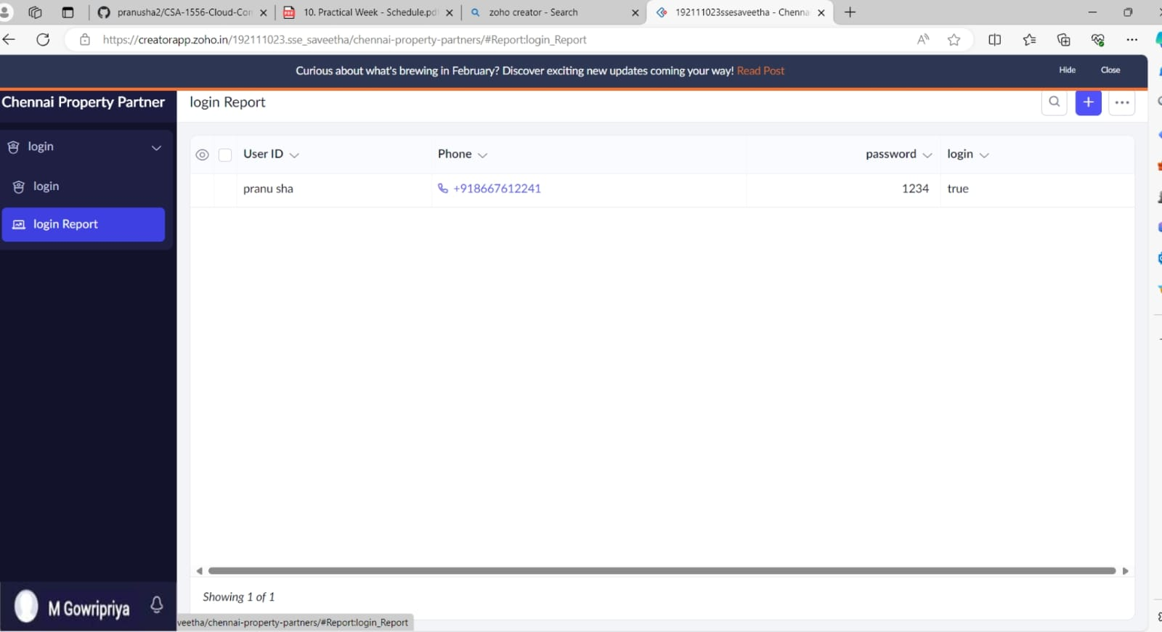

STEP 10: Select from Stratch and Create form as Rental Agreement.

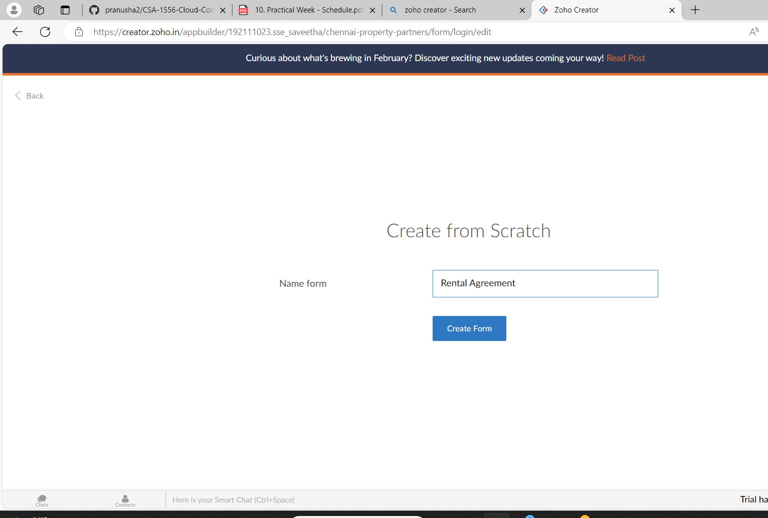

STEP 11: The form has been created as Rental Agreement.

Choose the fields.

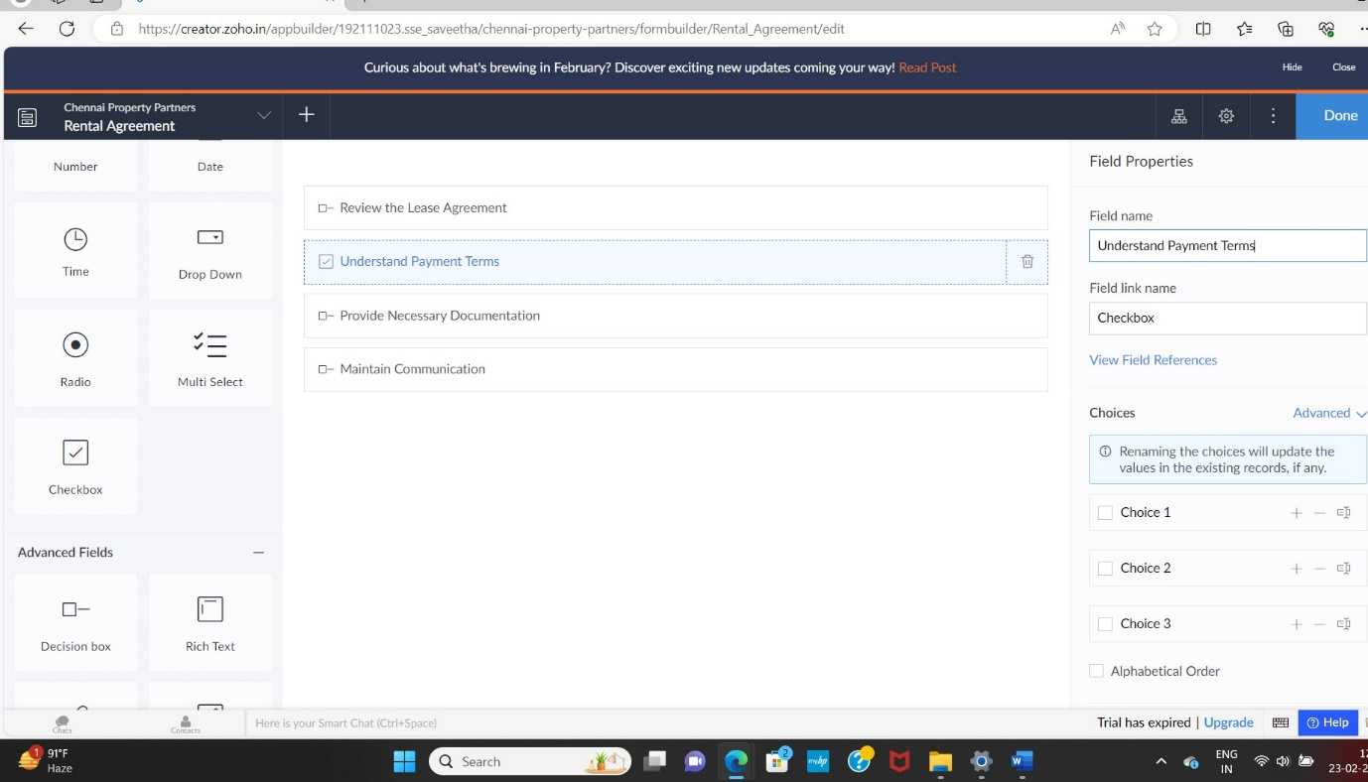

STEP 12: Click Access Development Live and enter the details to access

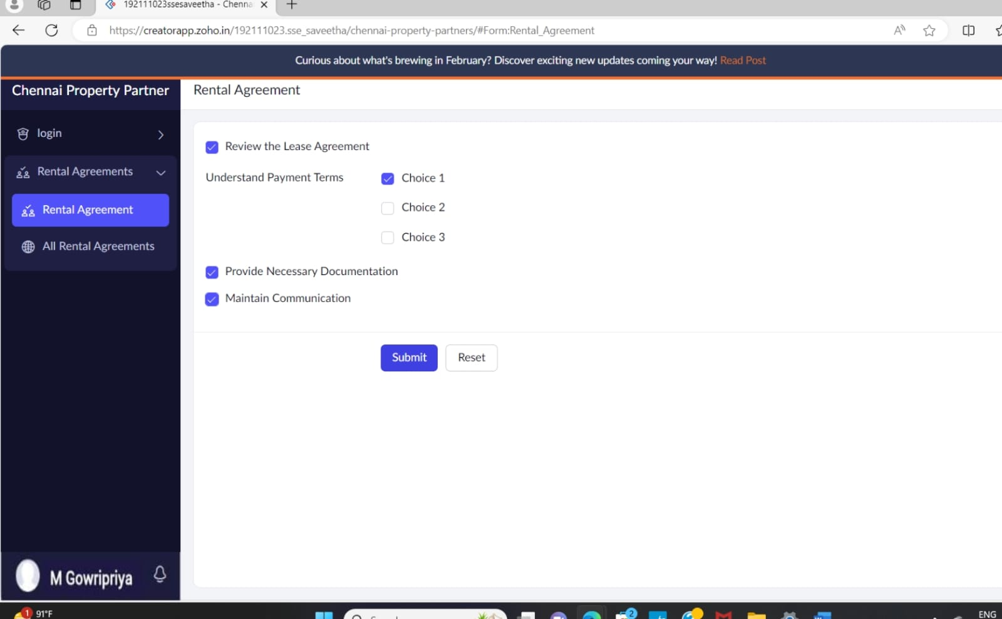

STEP 13: The report has been registered in the Rental Agreement report.

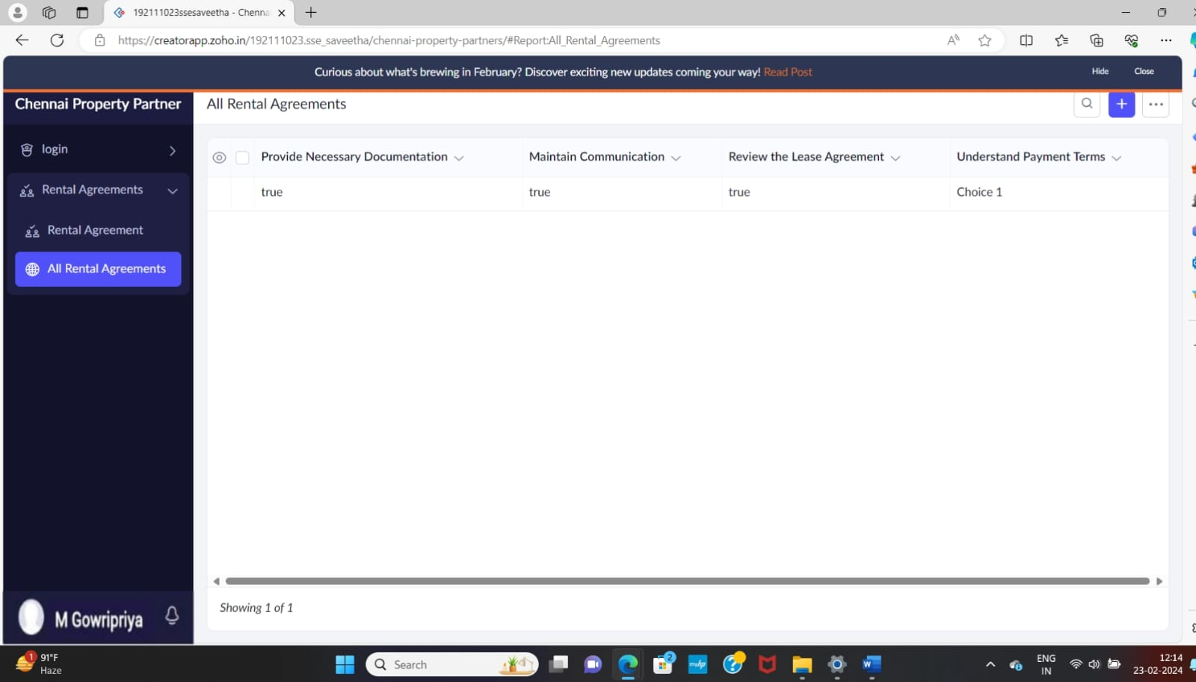

STEP 14: Select from Stratch and Create form as Property Description.

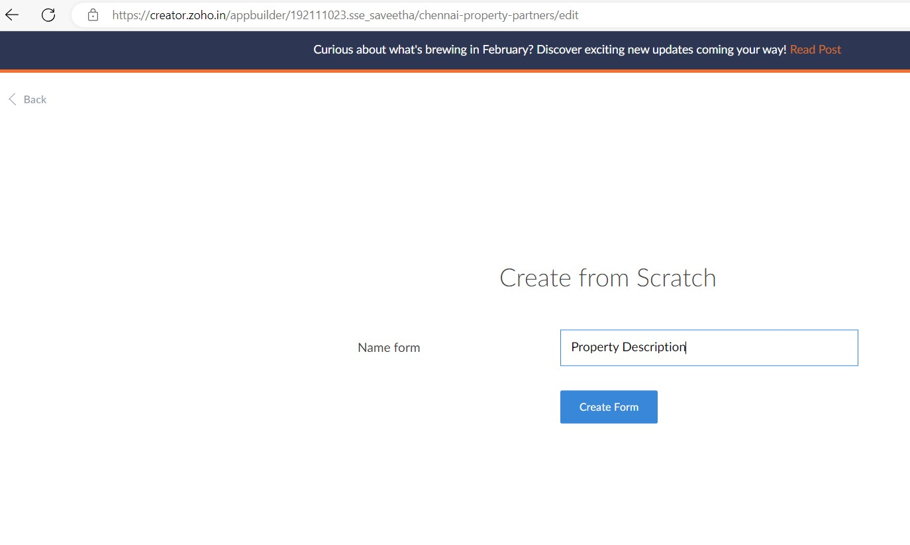

STEP 15: The form has been created as Property Description

Choose the fields.

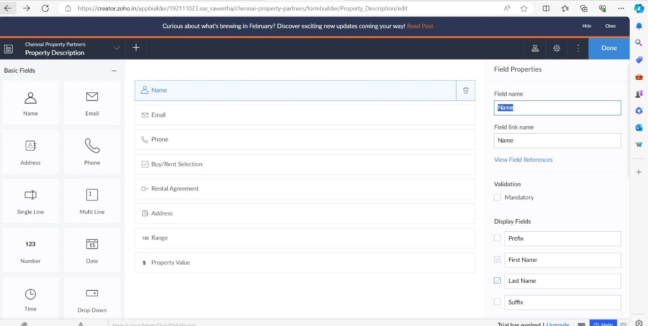

STEP 17: Click Access Development Live and enter the details to access

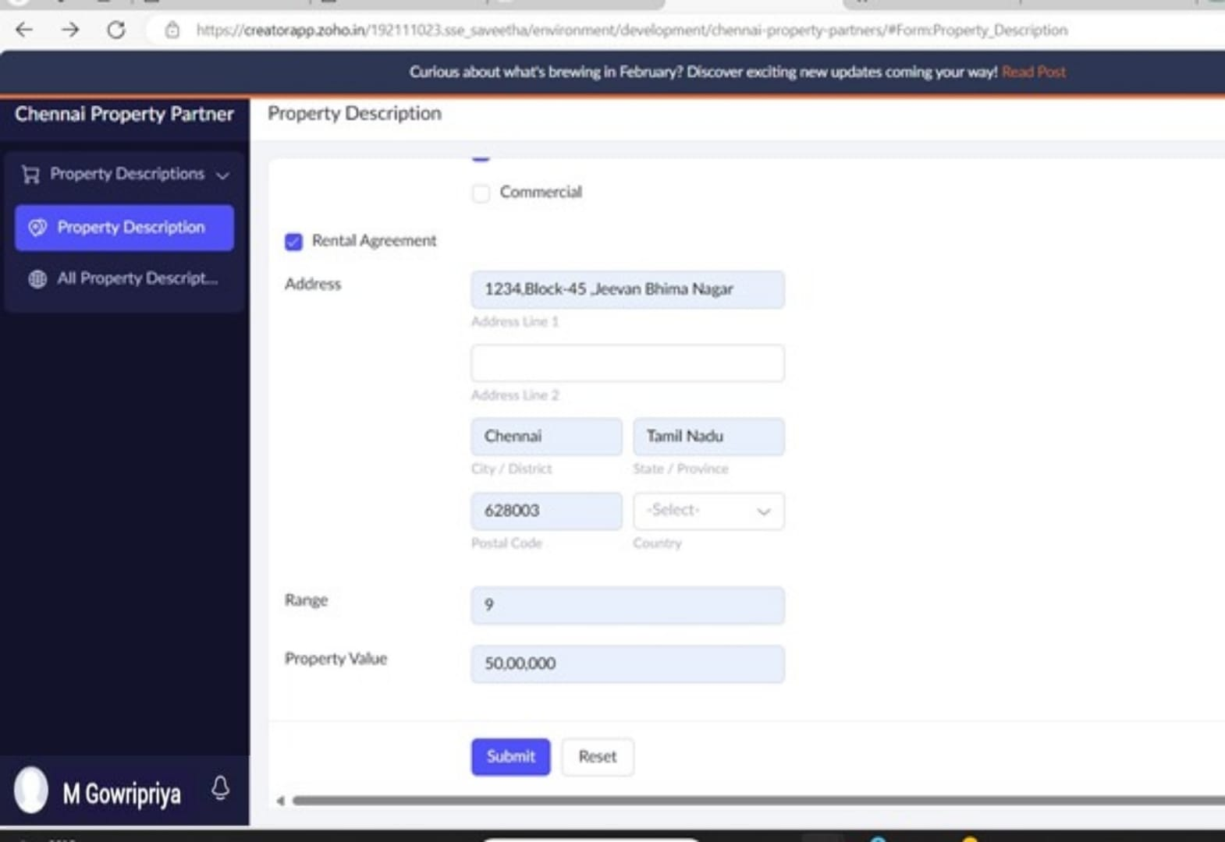

STEP 18: The report has been registered in the Property Description report.

